
LA GRANDEE INTERNATIONAL COLLEGE
Simalchaur, Pokhara, Nepal

A Mid-Term Report
on
StockEase

Submitted to
La Grandee International College
Bachelor of Computer Application (BCA) Program

In partial fulfillment of the requirements for the degree of BCA under
Pokhara University

Submitted by
Name | Program/Semester | PU-REGISTRATION NO
Yubaraj Pandey | BCA 6th SEM | 2021-1-53-0373
Pawan Poudel | BCA 6th SEM | 2021-1-53-0357

Date: 16/12/2024

Table of Contents
List of Figures iii
1. Introduction 1
2. Problem Statement 2
3. Objectives 3
4. Background Study 4
5. Methodology 5
6. System Design 6
6.1 DFD Level 0 6
6.2 DFD Level 1 6
6.3 ER Diagram 7
7. Project Progress Report 8
Milestones: 8
Tasks Remaining: 8
8. Conclusion 9
9. References 10

List of Figures
Fig 5.1: Agile Methodology 5
Fig 6.1. 1: DFD Level O 6
Fig 6.1. 2: DFD Level 1 6
Fig 6.1. 3: ER Diagram 7

Introduction
StockEase is an all-in-one solution designed to streamline stock and inventory management for businesses of all sizes. Whether you're managing a small retail store, a large warehouse, or an e-commerce platform, the platform provides real-time insights into stock levels, minimizing the risk of overstocking or running out of key products. Its user-friendly interface allows for smooth navigation through intuitive search filters, enabling precise tracking based on product category, location, quantity, and stock status.
For efficient inventory management, StockEase provides a streamlined solution tailored to meet the needs of administrators. The system currently includes key features such as admin login, the ability to add new items to the inventory, and a detailed view of all items in stock. Additionally, StockEase maintains a centralized database for the admin, ensuring secure and organized data storage for easy access and management. These foundational features enable administrators to keep inventory records up-to-date and ensure smooth day-to-day operations.
In its next development phase, StockEase will introduce several advanced functionalities to enhance its capabilities. Planned features include the ability to generate comprehensive reports for analyzing stock trends, sales performance, and inventory health. Real-time stock updating will allow administrators to modify inventory levels dynamically, ensuring accuracy and reducing the risk of stock discrepancies. The system will also incorporate customer management tools to track purchase histories and preferences, enabling more personalized and efficient service. Additionally, a secure logout feature will be implemented to bolster system security and safeguard sensitive information. These updates aim to make StockEase a comprehensive, user-friendly solution for modern inventory management.

Problem Statement
Managing inventory using traditional or outdated systems is becoming an increasingly challenging task for businesses today. The inefficiencies and limitations of current inventory management systems not only disrupt daily operations but also affect long-term growth and customer satisfaction. From delayed stock updates to lack of integration, the shortcomings of these systems create bottlenecks across various functions. The following are some of the key issues experienced by users:
- Current inventory management systems suffer from inaccurate stock tracking, manual data entry errors, lack of visibility across locations, slow order fulfillment, limited reporting capabilities, and poor system integration, leading to operational inefficiencies and reduced customer satisfaction.

Objectives
In the current digital landscape, businesses are increasingly turning to computerized solutions to enhance efficiency and streamline operations. An "Inventory Management System" is designed to meet this demand, providing various features that help improve business performance and optimize daily operations. Built to address key challenges, the main objective of this project is:
- Real-time stock tracking and order processing to streamline operations and reduce delays.
- Supplier management and financial monitoring to enable data-driven decision-making and improve accuracy.

Background Study
Inventory management has long been a critical function in businesses, playing a central role in ensuring that the products are available at the right time and in the right quantity. As technology has advanced, inventory systems have evolved from manual processes to highly sophisticated solutions. IMS Software by IMS Group in Nepal exemplifies this evolution by offering comprehensive tools tailored for businesses in diverse industries, including retail, hospitality, and manufacturing.
The evolution of technology introduced computerized inventory management systems, which offered significant improvements over manual methods. Early systems were primarily used by large-scale businesses to track stock levels, automate reordering processes, and reduce excess inventory. Over time, the adoption of inventory management systems expanded across industries, from retail and manufacturing to healthcare and hospitality, as more businesses recognized the need for precise inventory control to stay competitive.
Modern inventory management systems offer a wide range of features, such as real-time stock tracking, integration with sales and procurement systems, barcode and RFID scanning, and predictive analytics. These systems enable businesses to maintain optimal stock levels, reduce waste, and improve order fulfillment processes. Cloud-based solutions and mobile applications have further enhanced accessibility and ease of use, allowing businesses to manage their inventory from anywhere with real-time updates.
As businesses continue to face challenges such as fluctuating demand, supply chain disruptions, and changing customer expectations, the role of a robust inventory management system becomes even more crucial. An effective system helps businesses minimize stockouts, optimize warehouse operations, and provide accurate data for better decision-making, ultimately leading to improved customer satisfaction and increased profitability.

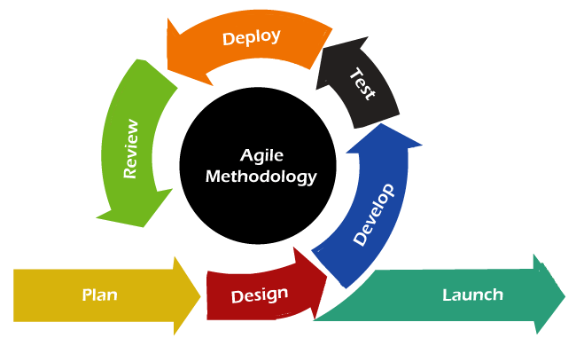
Methodology
Fig 5. 1: Agile Methodology

We are employing the Agile Methodology as our chosen approach for project development. This model follows an iterative process that emphasizes flexibility, collaboration, and continuous improvement. Agile is divided into short development cycles called sprints, which typically last 1-4 weeks. Each sprint involves planning, development, testing, and review, allowing teams to deliver incremental updates to the project.
In Agile, development is adaptive, with the ability to respond to feedback and changing requirements, promoting a collaborative environment between stakeholders and the development team. This iterative approach helps us remain flexible, deliver functional components quickly, and ensure that the final product evolves according to customer needs.

Fig 6. 1: Project Gantt Chart

6. System Design

DFD Level 0
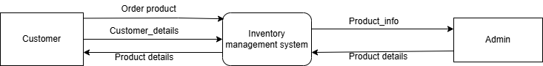
Fig 6.1. 1: DFD Level O

DFD Level 1
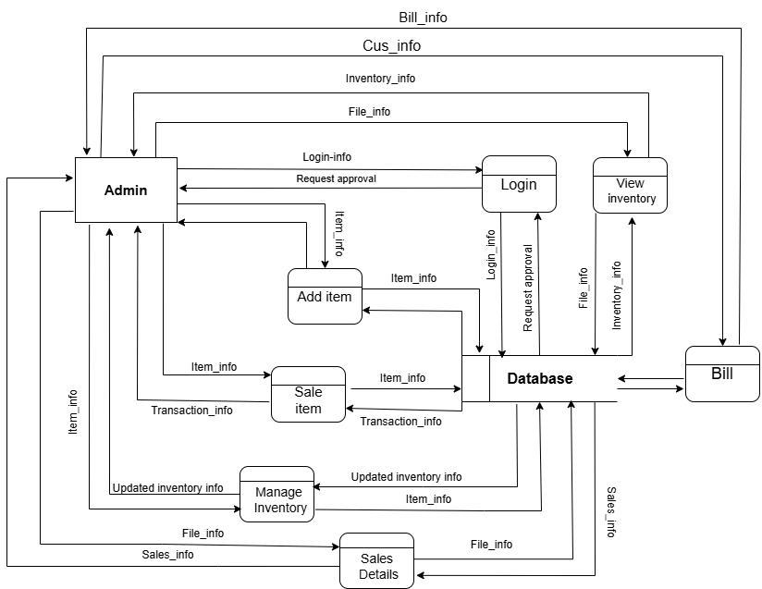
Fig 6.1. 2: DFD Level 1

ER Diagram
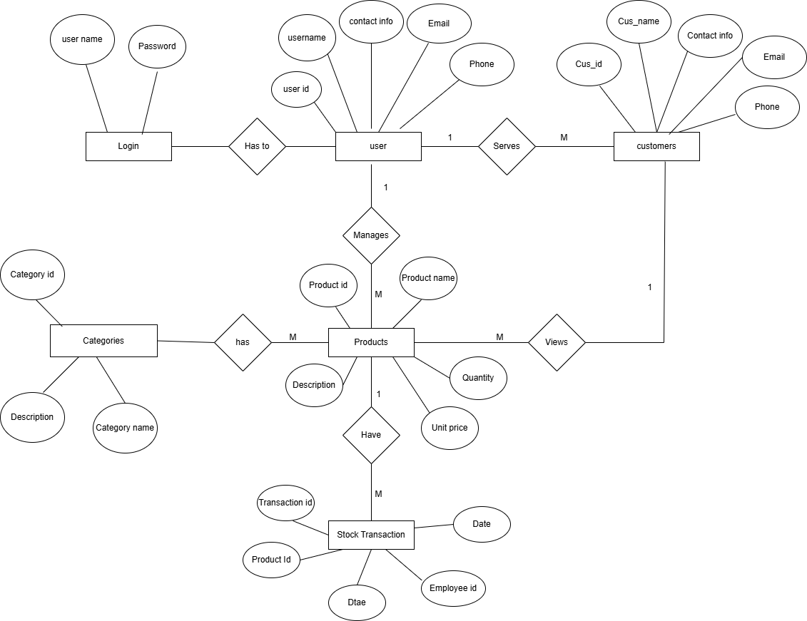
Fig 6.1. 3: ER Diagram

7. Project Progress Report

Milestones:
Here are some milestones we have achieved until the Midterm of the project:
- System Designs (DFDs, E-R Diagrams)
- Admin Login
- Add Stock
- View Stock
- Database of Admin

Tasks Remaining:
Here are some tasks remaining for the completion of the project:
- Generate Reports
- Update Stock
- Customer Management
- Logout Feature

8. Conclusion
StockEase has demonstrated significant progress as a midterm project, offering essential features for effective inventory management, such as real-time stock insights, secure admin access, and streamlined item tracking. The system's current functionalities lay a strong foundation for efficient stock handling, ensuring smooth operations for businesses of varying scales.
Looking ahead, the planned enhancements including advanced reporting, real-time stock updates, customer management tools, and improved security will further solidify its value as a comprehensive inventory management solution. The progress achieved thus far reflects a clear commitment to delivering a robust, user-friendly platform that meets modern inventory challenges.

9. References
(n.d.). Retrieved from https://www.unleashedsoftware.com/inventory-management-guide/inventory-management-systems/

